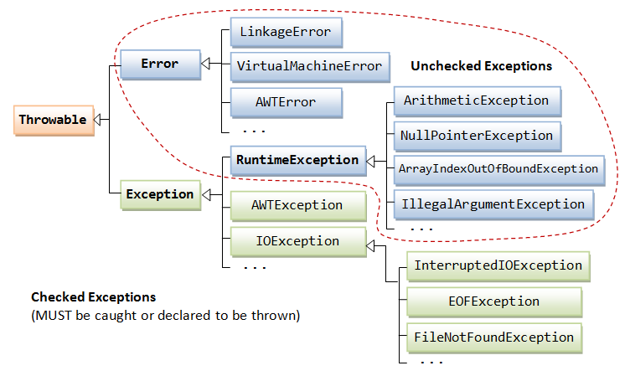

Simple Assignment Operator
= Simple assignment operator

Arithmetic Operators
+ Additive operator (also used
for String concatenation)
- Subtraction operator
* Multiplication operator
/ Division operator
% Remainder operator

Unary Operators
+ Unary plus operator; indicates
positive value (numbers are
positive without this, however)
- Unary minus operator; negates
an expression
++ Increment operator; increments
a value by 1
-- Decrement operator; decrements
a value by 1
! Logical complement operator;
inverts the value of a boolean

Equality and Relational Operators
== Equal to
!= Not equal to
> Greater than
>= Greater than or equal to
< Less than
<= Less than or equal to

Conditional Operators
&& Conditional-AND
|| Conditional-OR
?: Ternary (shorthand for
if-then-else statement)

Type Comparison Operator
instanceof Compares an object to
a specified type

Bitwise and Bit Shift Operators
~ Unary bitwise complement
<< Signed left shift
>> Signed right shift
>>> Unsigned right shift
& Bitwise AND
^ Bitwise exclusive OR
| Bitwise inclusive OR
« Previous • Trail • Next »

